Deep Research on UPI

Written by Jonathan Zhang

**Definition of UPI**

UPI, short for Unified Payments Interface, is a singular mobile platform where funds can be transferred across participating banks instantaneously [1]. It is meant to promote financial inclusion and decrease reliance on cash. Simply said, one person can transfer funds between two different banks from their smartphone and the transfer goes through immediately.

**Context**

        Before UPI, in an attempt to convert India’s economy to electronic funds transfer, a group of payment systems, sometimes called payment rails, were established. Examples of these payment systems include such as NFS (National Financial Switch), NEFT (National Electronic Funds Transfer), and RuPay [2]. These systems are still active today and are used for specialized payments. The drawback is that none of the options gave universal, constant access to funds and the ability to pay across institutions. For example, NEFT helped with transfers between banks, but the banks had to be a part of NEFT and transfers did not occur in real time [2]. The issues that existed were lack of security, ability to integrate multiple banks, and convenience. UPI uses these organizations and brings them all under one interface.

        Last year (2017), the recorded number of smartphone users was 370 million [3]. That number is expected to climb upwards of 500 million by 2022 [3]. This increase in access to technology is favorable for the implementation of UPI. Another factor that has led to the rise of UPI is the Aadhaar program. The Aadhaar initiative gave 92% of Indians a “digital identity based on biometric and demographic data,” which is useful for identification [2].

**NPCI’s Involvement**

The National Payments Corporation of India, or NPCI, is "an umbrella organization for operating retail payments and settlement systems in India" [4]. NPCI was the original pioneer of UPI, which presented itself as a potentially groundbreaking innovation in the world of finance technology. UPI's pilot launch by NPCI occurred on April 11th, 2016 under the oversight of Dr. Raghuram G. Rajan [1]. NPCI is still the sole operator of UPI, but companies and startups have taken the idea and made different forms of it.

**What UPI Does**

UPI has a variety of streamlined financial processes that set it apart from traditional banking and fund transfer. Without the assistance of mobile and electronic technology, cash, check, or card have to be used to transfer payment from one entity to another. UPI eliminates the need for physical transactions by incorporating all parts of payment into one interface [2]. In fact, UPI is more convenient and faster than other methods, even competing electronic transfer apps. The superiority of UPI to its alternatives is detailed under ‘Advantages of UPI’ below.

Through UPI, a person can pay someone for a good or service through the app by making a pay request [5]. A pay request simply means that the payer is putting a request through the UPI app to send a certain amount of money to the payment receiver [5]. Similarly, a collect request can be made to ask for payment from a payer; the payer will get a notification and can choose whether to pay or not [5]. This inclusion of collect requests is new to India and allows for receivers to demand payment.

**UPI’s Structure**

**Figure 1** is a diagram that shows the flow of information when a fund transfer is made. It is important to understand the mechanics of this diagram to understand how UPI operates.

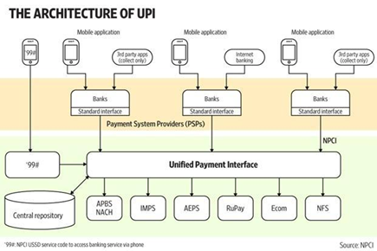  
**Figure 1:** The Architecture of UPI- Illustration of UPI and its connection to the app, bank insitutions, and payment systems. Retrieved from Reference [6].

        The first step of using UPI is the execution of a transfer. Through Payment Service Providers, or PSPs (shown by the phones in **Figure 1**), the transfer of funds can be arranged and that data is sent to the main UPI [6]. These PSPs are responsible for the management of the website or app where the transfer occurs, but it is important to note that PSPs may not be part of banking institutions [6]. PSPs must have a connection with the bank that the user is extracting funds from in order to complete a transfer [6]. PSPs are accountable for making sure that two-factor authentication is used in the payment process and that it is secure [2]. The user must first complete authentication, and then he or she now has access to the funds in the bank account, which is shown through the provider’s app or website [2]. UPI uses Aadhaar IDs as an option during the two-step authentication process [2].

Since UPI is connected to many participating payment rails (**Figure 1** includes APBS + NACH, IMPS, AEPS, RuPay, Ecom, and NFS), it can aid in cross-entity transfers, as long as those entities are participating in UPI as financial institutions [6]. In order for UPI to send the payment to another party, the payer has to enter some sort of identification of the receiving party [2]. Some identifiers include the receiver’s Aadhaar ID, mobile number, or bank account number [2]. Another form of identification is a Virtual Payment Address (VPA), which is similar to an email address, and any person can choose what their VPA is for different PSPs [2]. VPAs allow for transactions to occur without giving away sensitive information. Once the user has entered a transaction amount and the credentials of the receiver, the payment goes through UPI to the receiver’s PSP [7]. UPI sends the information of the payment through the involved banks and payment rails and the transaction is complete.

As **Figure 1** shows, Unified Payments Interface allows for different standard interfaces of bank accounts and 3rd party apps to be integrated together, which is the concept that differentiates UPI from any other previous electronic transfer app.

**Advantages of UPI** [2,5,8]

Note: The ‘alternatives’ mentioned in the list below include competing electronic transfer systems similar to UPI.

1. Instantaneous: Transfers conducted with the correct authentication that run through UPI are done immediately, even if they are across institutions. Alternatives have to process transfers after they come through and this can take up to 24 hours.
2. 24 / 7 / 365 Service: Transfers can be conducted anytime during the year since UPI integrates multiple financial institutions’ systems together in one app. This means that UPI can take care of everything without communicating with the institutions involved. Alternatives do not have 24 / 7 service and may be shut down during holidays.
3. Secure: UPI uses two-factor authentication, which can consists of the M-Pin that must be made with the UPI app and confirmation of the user’s mobile SIM. This information stays with UPI and is not shared. Alternatives must share your credentials when making a cross-institution transfer, but UPI does not require this intermediate step, where information can be stolen or incorrectly communicated.
4. Interoperable: Suppose a person needed to access multiple banks to make multiple payments. Since many banks are associated with UPI, the person doesn’t have to leave the app to make different transfers. Alternatives would require the person to visit each bank’s individual app to access the account.
5. Convenient: A person’s payment information such as VPA and other credentials can be stored on the UPI app, meaning that the details only have to be given once. Some alternatives require that the user input their details for every transaction.
6. Complaint System: Alternative apps have separate places where people troubleshoot and give complaints, but UPI allows for complaints to be filed directly from the app.
7. Versatile: While alternative payment systems are meant for exclusively sending funds, making payments, or getting funds, UPI is able to do all of them.

**UPI’s Growth**

So how fast is UPI growing? In light of its advantages over other systems, it may change the way India’s economy is structured. Credit cards are a popular way of making transactions in India, with Visa and MasterCard being two of the top choices. However, the total transaction rate of debit and credit cards has diminished since UPI’s launch [9]. This is seen in **Figure 2**.

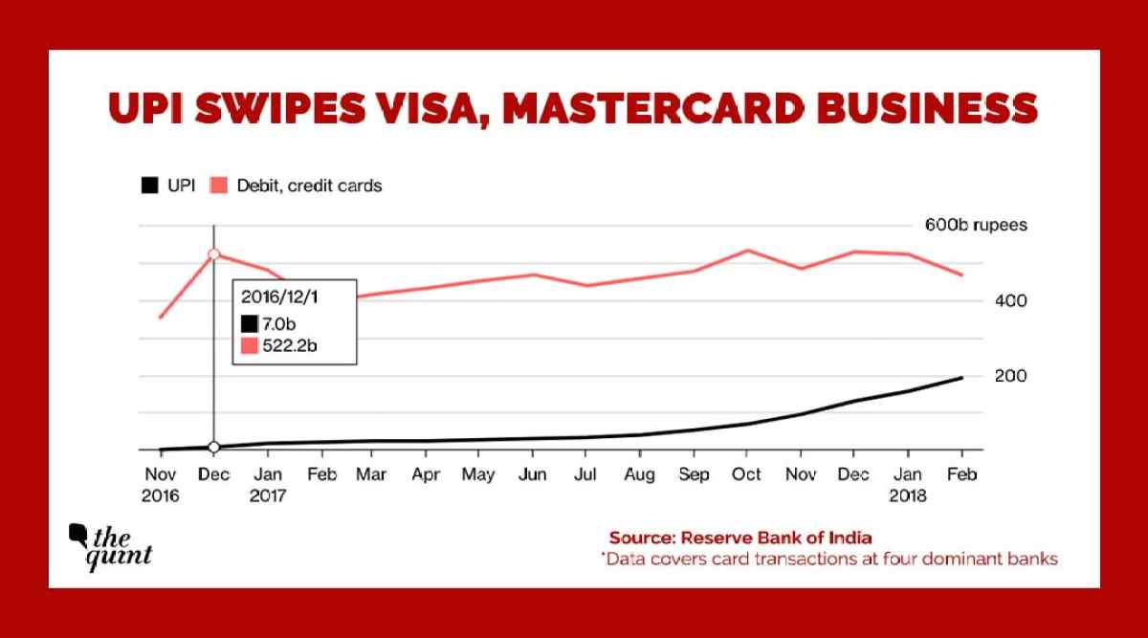  
**Figure 2:** Trendlines of UPI v. Card- UPI shown in black (bottom) and card shown in red (top). Data recorded from Dec 2016 to Feb 2018. Total transaction value on y-axis in rupees. Retrieved from Reference [9].

The Reserve Bank of India (RBI) recently published that “over 151 million transactions were done via UPI between January 2017 and December 2017,” which is a result of UPI’s 57000% growth in users, compared to card only experiencing 20% user growth [9]. Keep in mind that UPI only launched the year before the previous statistic was made. UPI will definitely remain relevant in India’s economy for a long time, and many are saying that it will usher in the ‘economy of the future.’ UPI has grown from a base of 21 banks from launch to 122 banks as of September 2018 [10]. Along with increasing user base and bank participation, UPI is still improving its software, and NPCI recently released version 2.0 of UPI. The explosion of UPI’s popularity since it launched holds great promise for the future of purely electronic economy.

**Getting Started With UPI** [11]

The NPCI has its own app called BHIM. This start guide details how BHIM can be set up, but many UPI apps have similar function and structure, as they all run through the same interface in the end.

1. Download BHIM from the app store.
2. Select language.
3. Accept the prompts to give the app permissions.
4. Select your SIM. The app will check your SIM and use that to identify your mobile phone. Now, only your phone can be used to send transactions with your information through UPI.
5. Create a passcode. You will need to enter this everytime the app is opened.
6. Choose your bank.
7. The app will use your SIM information to get your bank account details directly. Your bank account should show up.
8. Add the account.
9. Now you can make payments and requests through the account’s home page.

On the BHIM app, you can switch between multiple linked bank accounts.

For a visual guide, please reference this YouTube video: <https://www.youtube.com/watch?v=DfpY2VkHDI0> [11].

**FAQ (Frequently Asked Questions)**

The following FAQs were retrieved from NPCI’s official website, and they address general issues that people may have with UPI or questions about UPI [12].

*What is UPI? What does it do for me?*

Unified Programs Interface, or UPI, is meant to allow a person to transfer funds from one bank to a different bank. You can make transactions instantaneously and everything is electronic. You also can access multiple bank accounts through one app.

*Why does my bank account not show up when I select my bank?*

You need to make sure that your mobile number is the same number that you registered to the bank with.

*How do I order items online with UPI?*

UPI can be a payment option when ordering online. The website will require your payment address and you will receive a collect request to approve.

*What do I do if I paid for my transaction but have not received confirmation or any details about it?*

Sometimes the operator can run into issues and it will take longer to process a transaction. If you do not receive information within 1 hour, contact us.

*Can I link a mobile wallet to UPI?*

No, only bank accounts can be added.

*Does the person receiving payment have to be registered with UPI?*

When using Virtual Payment Address to reference the beneficiary (person receiving), the other person should have a VPA linked to a UPI account. If you use some other form of identification for the beneficiary, then they do not have to be linked to UPI.

*What if I lose my phone?*

Your UPI pin would protect from anyone accessing your account, but you can also block your mobile number from executing transactions by contacting us.

*Can I have the same Virtual Payment Address for all my bank accounts?*

Yes, but this may depend on the PSP that you are using.

*Is it possible to stop a payment once I complete a transaction request?*

No, once the payment is made through UPI, it cannot be stopped.

*What is the fund transfer limit?*

Currently, it is set at 1 lakh or 100,000 rupees.

*What do I do with my information if I change my UPI app?*

You need to complete the registration again and make a new VPA (you can choose the same one as old one) through the new PSP.

*How do I change my PIN if I forgot it?*

You would need to provide the last six digits of your debit card information and the expiration date.

*What happens if I change SIM or mobile number? What about my mobile carrier?*

You need to change the mobile number with the bank and re-register for UPI. If the carrier changes, UPI will still work.

*What platforms is UPI available on?*

iOS and Android

*How is my bank account information getting retrieved by UPI?*

UPI is operated by NPCI, which uses a method of retrieving account details linked with your phone number without being able to save or see any personal information. The details are never stored or used arbitrarily by UPI.

*Can I use two or more UPI apps on my phone?*

Yes, and you can link them to the same or different bank accounts if you wish.

**References**

[1]

UPI: Here's What You Must Know About This New-Age Payment Mode. (2017, April 12). Retrieved October 24, 2018, from <https://www.tomorrowmakers.com/financial-planning/upi-heres-what-you-must-know-about-new-age-payment-mode-listicle>

[2]

Desai, S., Jasuja, N., & Khandekar, P. (2017, May 11). Your guide to UPI — the world’s most advanced payments system. Retrieved October 24, 2018, from <https://medium.com/wharton-fintech/your-guide-to-upi-the-worlds-most-advanced-payments-system-b4e0b372bf0b>

[3]

Kedem, S. (2018, April 16). Does India have the world’s fastest growing smartphone market? Retrieved October 24, 2018, from <https://www.verdict.co.uk/indias-smart-phone-users/>

[4]

About Us. (2017, December 08). Retrieved October 24, 2018, from <https://www.npci.org.in/about-us-background>

[5]

UPI Product Overview. (2017, September 29). Retrieved October 24, 2018, from <https://www.npci.org.in/product-overview/upi-product-overview>

[6]

How UPI Works. (2016, April 11). Retrieved October 24, 2018, from <https://www.livemint.com/Industry/bTGwxmykXhSKX5Vf8050NI/How-UPI-works.html>

[7]

(2016, October 02). Retrieved October 24, 2018, from <https://www.youtube.com/watch?v=XHOPaHWDH4g>

Channel: Ns Toor

[8]

How you can send and receive money using UPI or Unified Payments Interface. (2018, February 09). Retrieved October 24, 2018, from <https://www.rupeeiq.com/content/how-you-can-send-and-receive-money-using-upi-or-unified-payments-interface/>

[9]

Aadeetya, S. (2018, April 03). UPI Payments Growing Faster Than Visa and MasterCard in India . Retrieved October 24, 2018, from <https://www.thequint.com/tech-and-auto/tech-news/digital-payment-india-debit-cards-growth-pales-with-rise-of-upi>

[10]   
UPI Product Statistics. (2018, October 01). Retrieved October 24, 2018, from <https://www.npci.org.in/product-statistics/upi-product-statistics>

[11]

(2017, June 02). Retrieved October 24, 2018, from <https://www.youtube.com/watch?v=DfpY2VkHDI0>

Channel: NPCI

[12]

UPI FAQ. (2018, October 01). Retrieved October 25, 2018, from <https://www.npci.org.in/upi-faq-s>